**ISCWSA**

**Probabilities of Collision or Crossing**

**Normal Distribution**

|  |  |
| --- | --- |
| **Author: T. Torkildsen** | **December 2014** |

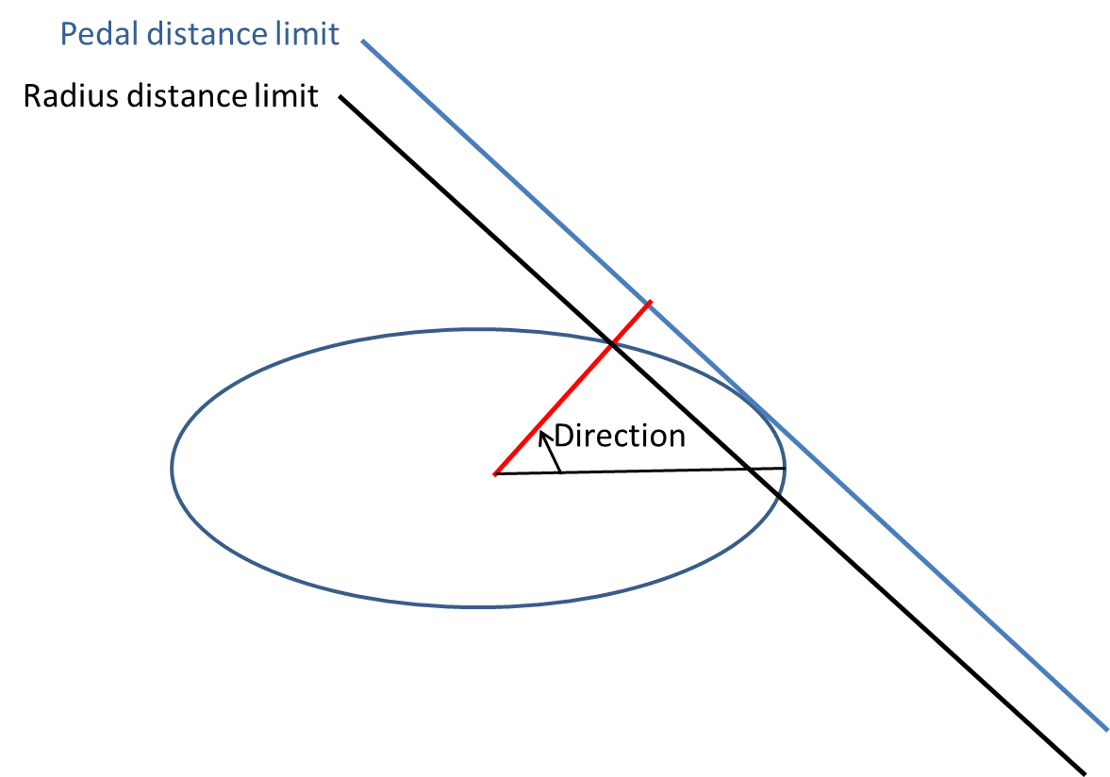

Nomenclature

Scaling factor - Scaling of standard ellipse (ellipsoid)

Flattening - Flattening of ellipse; (major-minor)/major

Probability - Probability of drilling on wrong side of limit line (plane)

Radius dist. - Distance from center to ellipse along Direction

Pedal distance - Distance from center to the ellipse’s pedal curve (surface) along Direction

Direction - Direction relative to major axis

