Standard set of well paths for use in evaluating clearance calculations

May 2017

Revision History
Date | Comment
10 Oct 2012 | Initial release
10 Oct 2013 | Add offset 11
9 Feb 2017 | Update tool model to ISCWSA MWD r4, and ISCWSA SF

Contents
Introduction p2
Welllpath Descriptions p2
Plan View p3
3D View p4
Set-up Instructions p5
Wellpath Listings p6

Introduction

This document was written in response to requests for a standard set of well separation scenarios that will allow comparison between clearance scanning rules under a range of proximity conditions and also test agreement between implementations of the same rule in different software. The well set fulfills a similar role to the standard ISCWSA well profiles defined in for use in validating error model implementations.
The set consists of 1 reference well and 11 offset wells. The relationship between the reference well and each offset well is considered individually. No offset to offset clearances are considered.
As with the ISCWSA standard error model well set, it is important to set up the wells correctly. Detailed instructions are provided in the Set-up Instructions section. Before using these wellpaths to evaluate more complex clearance calculations, users should first ensure that they obtain wellpath coordinates, position uncertainties and “center to center” clearance distances that agree with the definitive listings provided in the embedded workbook.
The well set can be used with any error models, but the uncertainty values included in the wellpath listings are based on the ISCWSA MWD rev 4 model. The Implementation of the ISCWSA model may vary slightly between programs, but if the wells have been set up correctly, agreement with the uncertainties reported in the definitive listing is expected to be good to the second decimal place for values greater than 0.3m.
The clearance results include a calculation of the ISCWSA Separation Factor (SF) as detailed in SPE 187073. Agreement with the results is expected to be within one decimal place for values less than 10.

Wellpath Descriptions

Wellpath name | Relationship to Reference Welllpath
Reference | Reference wellpath. 2DJ to 85 deg inc, due south, then horizontal
Offset 01: East 100 | Parallel to reference, offset 100m to the east
Offset 02: North 100 | Parallel to reference, offset 100m to the north
Offset 03: East 10 | Close top hole, then crossing reference at shallow incident angle
Offset 04: East 20 | Close top hole, approaching then diverging at shallow angle
Offset 05: Angular | Approaching at depth at an acute angle
Offset 06: Overlap opposite | Approaching at 180deg relative azimuth and overlapping
Offset 07: Short opposite | Approaching at 180deg relative azimuth and stopping short
Offset 08: Perpendicular | Approaching at 90deg relative azimuth
Offset 09: Vertical | Vertical well intersecting 85 deg inc. tangent
Offset 10: Sidetrack from MD 900m on reference | Sidetrack that diverges from then approaches the reference well
Offset 11: Horizontal approach | Approaching on horizontal plane at 90deg relative azimuth

Plan View
Reference well in blue
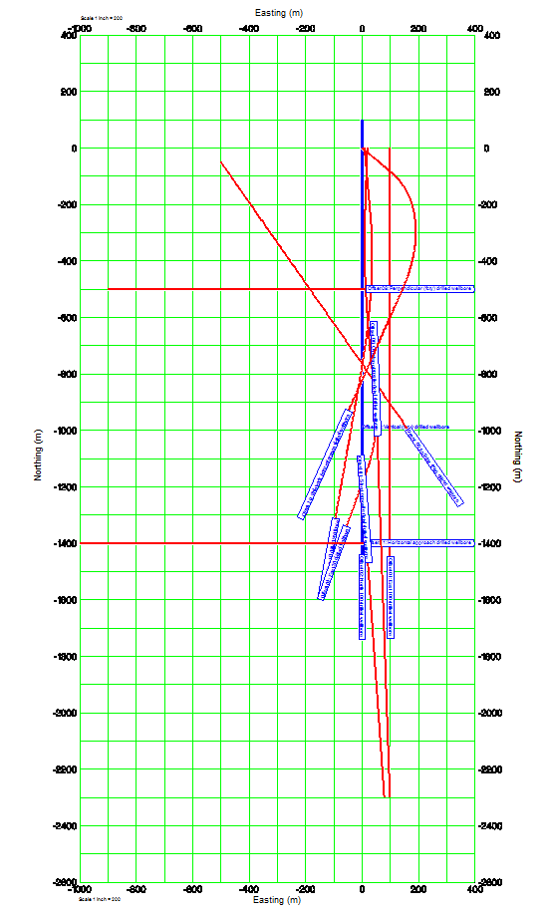

3D View
Reference well in blue

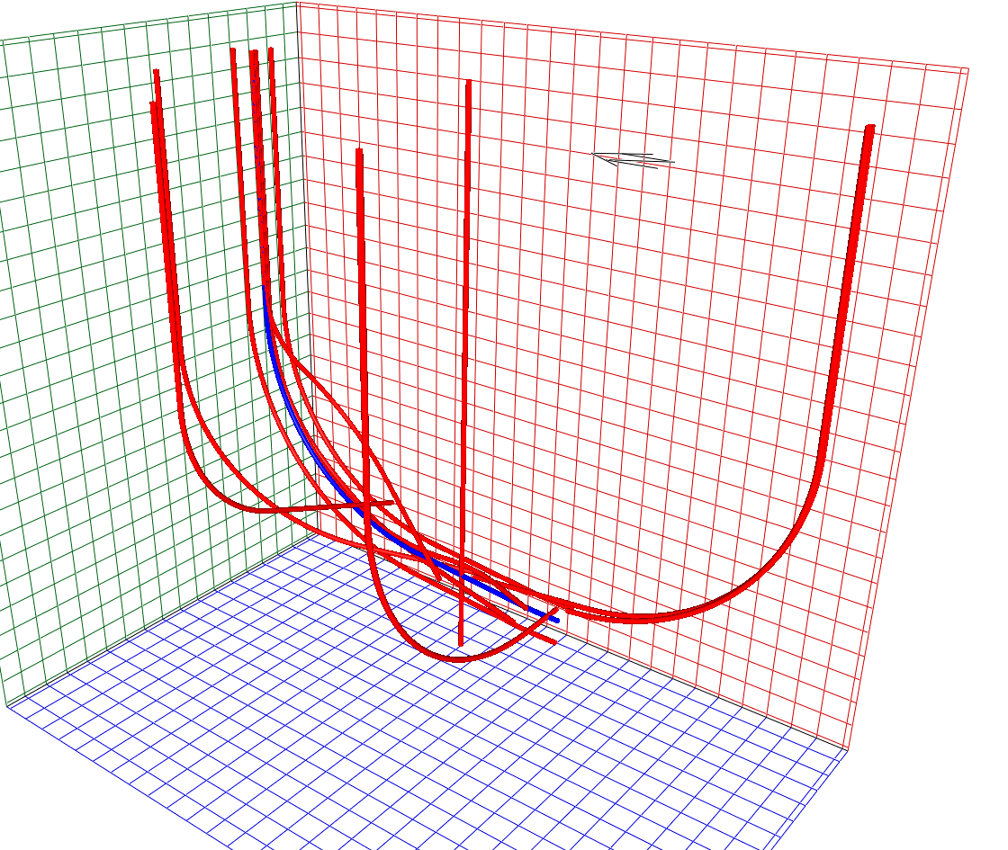

Set-up Instructions

Coordinates
- All well locations are defined in the ED 50 / UTM 31 N coordinate system (EPSG:23031, which uses the Hayford International 1924 ellipsoid)
- The wells are grouped in a single Facility (or Installation or Structure, or etc)
- The Facility reference point is at 60°N, 3°E, with elevation zero (the physical description of the datum is irrelevant, but can be assumed to be ellipsoid height, MSL or a national datum)
- All well path coordinates are reported in a local coordinate system
- The local coordinate system is aligned to UTM grid north and its origin (0N, 0E, 0 elevation) is the Facility reference point
- Each well path is defined by a single survey log, not a plan profile
- All survey logs have 30m survey station intervals, through build, turn and tangent intervals
- All survey logs have zero measured depth at Facility vertical datum
- All survey log azimuths are assumed to be referenced to Grid North, such that two distantly separated wells drilled on the same grid referenced azimuth will plot as parallel in a plan view

Position Uncertainty
- All wells have the following reference field parameters, applicable over the entire well path:
  - Declination: 0.00°
  - Dip: 70.00°
  - Field strength : 50000nT
  - Gravity: 9.80665m/s²
- All surface location uncertainties are zero
- Position uncertainty is calculated from zero measured depth
- Positional uncertainty is calculated using the no bias terms version of the ISCWSA MWD rev4 basic model for fixed installations.
- Outputs are reported at 1 standard deviation, half axis, in the HLA / borehole axis frame of reference to be consistent with SPE 67616.

Clearance scanning
- Clearance distances are calculated along the line of 3D closest approach
- When included, the diameters of the wells are:
  - Reference well, 36” from surface to TD
  - All offset wells, 24” from surface to TD
- Uncertainty for clearance purposes between the reference wellpath and its sidetrack (Offset 10) is calculated using the current common practice of zeroing the uncertainty for both wells at the deepest common point (i.e. the kick-off point).
- The ISCWSA / SPE WPTS separation factor is calculated using the values as documented in SPE 1877073:
  - Surface margin, S_{m}: 0.3m
  - Scaling factor, k: 3.5
  - Project ahead uncertainty, σ_{pa}: 0.5m

Wellpath Listings

